**COMSATS** **University Islamabad, Lahore Campus**

**Department of Computer Science**



**Assignment 2 – Semester Spring 2021**

|  |  |  |  |  |  |  |  |  |
| --- | --- | --- | --- | --- | --- | --- | --- | --- |
| Course Title: | Programing Fundamentals | | | | Course Code: | CSC103 | Credit Hours: | 4(3,1) |
| Course Instructor/s: | Tahir Muhammad | | | | Program Name: | BSE | | |
| Semester: | 1st | Batch: | Sp21 | Section: | C | Date | 17/4/2021 | |
| Student’s Name: | **Muhammad Talha Shafiq Choudhary** | | | | Reg. No. | SP21-BSE-008 | | |
| **Important Instructions / Guidelines:**   * Submission will be on **Turnitin** and in **printed form**. * Use front page while submit it in printed form. * Do not copy code from internet else you will be awarded with a zero. * Online Submission Deadline **19-04-2021 11:59 PM** | | | | | | | | |

**Q1:** Write the C Language program code to arrays (Array1 and Array2) with constant values and mergers these arrays into a 2D array (Named as Array3). While merging the given arrays you will have to follow a specific pattern in which each row even columns will store values and Array1 and off columns will store values from Array2. After merging you will have to print all of your arrays in the format shown below.

**Array1 = {10, 20, 30, 40, 50, 60, 70, 80}**

**Array2 = {90, 100, 110, 120, 130, 140, 150, 160}**

*Hint: Use two loops in nested format to control rows and columns of 2D array*

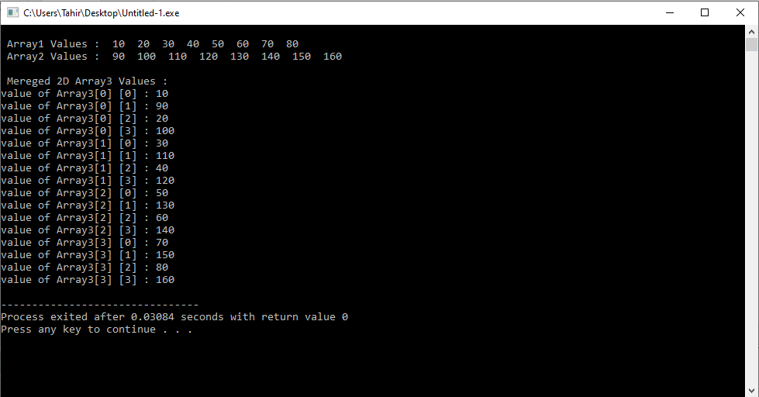

**Best of Luck! 😊**

**Put Your Solution Here**

|  |
| --- |
| **Solution:**  **#include<stdio.h>**  **int main()**  **{**  **int Array1[8]={10,20,30,40,50,60,70,80};**  **int Array2[8]={90,100,110,120,130,140,150,160};**  **int Array3[4][4];**  **int i,j;**    **printf("\n Array1 Values : ");**  **for(i=0;i<8;i++)**  **{**  **printf(" %d",Array1[i]);**  **}**  **printf("\n Array2 Values : ");**  **for(i=0;i<8;i++)**  **{**  **printf(" %d",Array2[i]);**  **}**  **printf("\n\n");**  **printf("-----Muhammad Talha Shafiq--------\n");**  **printf("-----------SP21-BSE-008-----------\n");**  **printf("\n");**  **int k=0;**  **for(i=0;i<=3;i++){**  **for(j=0;j<=3;j=j+2) {**  **Array3[i][j]=Array1[k];**  **Array3[i][j+1]=Array2[k];**  **k=k+1;**  **}**  **}**  **for(i=0;i<=3;i++){**  **for(j=0;j<=3;j++) {**  **printf("\nValue of Array3[%d] [%d] : %d",i,j,Array3[i][j]);**  **}**  **}**  **return 0;**  **}** |